Creating a database using Microsoft Access
Microsoft Access provides two methods to create a database:
1 The Database Wizard allows you to create (in one operation) the required tables, forms, and reports for the type of database you choose. This is the easiest way to start creating your database. You can modify and extend your database at any time after it has been created.
2 You can create a blank database and then add the tables, forms, reports, and other objects later. This is the most flexible method, but it requires you to define each database element separately.

Using the Wizard
When Microsoft Access first starts up, a dialog box is automatically displayed with options to create a new database or open an existing one. To use the Wizard, click Database Wizard, and then click OK. The screen is shown below:
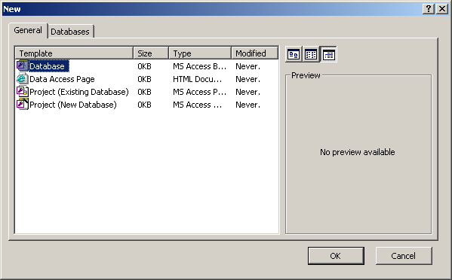
If you have already opened a database or closed the dialogue box that displays when Microsoft Access starts up, click New Database on the toolbar.
On the Databases tab, double-click the icon for the kind of database you want to create. Shown below is the selection of an Inventory Control database.
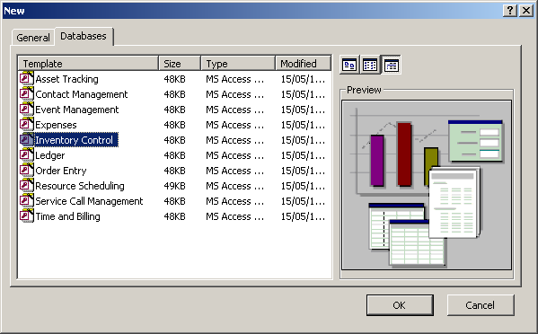
After you click the OK button, specify a name and location for the database.
Click Create to start defining your new database. The Wizard will guide you through all stages of creating the database and various database objects.
Example screen shots are shown below:
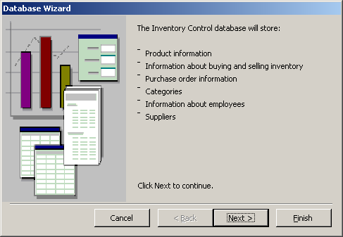
Clicking the Next button results in the following screen, where you can add or remove fields:
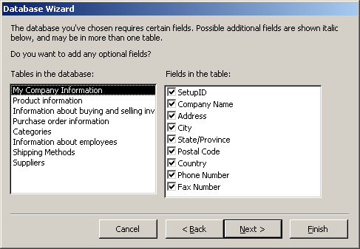
After clicking the Next button a screen is displayed where you can choose a subject, as shown here:
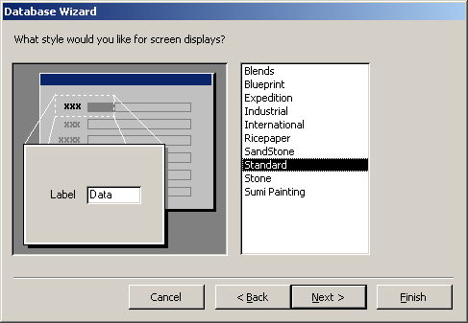
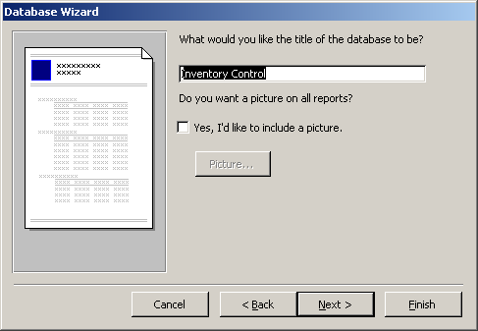
After clicking Next, you are prompted for a title for your database, as follows:
When you tick the Yes, start the database checkbox on the resulting screen (shown below) and the Finish button, your database will be displayed, ready for you to enter data.
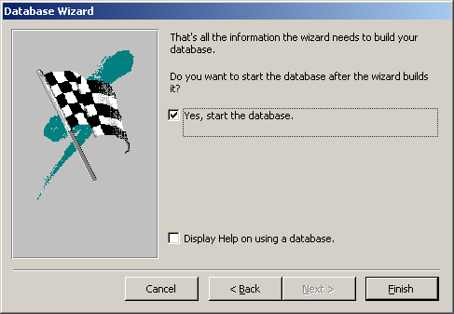

Creating a database from scratch
When Microsoft Access first starts up, a dialogue box is automatically displayed with options to create a new database or open an existing one. To create a database from scratch, click Blank Database, and then click OK. The resulting screen is shown below:
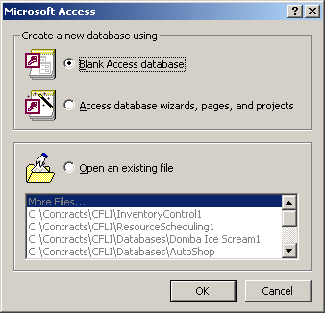

If you have already opened a database or closed the dialog box that displays when Access starts up, click New Database on the toolbar, and then double-click the Blank Database icon on the General tab.
Specify a name and location for the database and click Create.
After you create a blank database, you must perform additional steps to define the objects that will make up your database. In the screen below these objects are listed on the left. Start with tables.
